

**MATERIAL COMPLEMENTAR**   
A1: Introduction of the course

Profa. Priscila Carletti

FOCUS ON **LISTENING**

**Handout Aula 1 - Introduction of the course**

Today:

* What is listening?
* Food for thought: challenges to understanding spoken English
* Pronunciation
* Fast speech and accents
* Myths about monolingualism
* Poem
* Tips for a better listening comprehension

**Warm up**

Em uma escala de gatos, como você está se sentindo para a aula hoje? 👀 How are you feeling for today 's class?

Also, what do you hope to learn in this course?

What is listening to you?

**Introduction**

What is listening?

From the British English

1. A. the act of concentrating hearing something

B. (as modifier) a listening device

1. The act of paying attention

Good listening is good parenting he did all the talking, I did all the listening

**What is listening?**

Listening is receiving language through the ears. Listening involves identifying the sounds of speech and processing them into words and sentences. When we listen, we use our ears to receive individual sounds (letters, stress, rhythm and pauses) and we use our brain to convert these into messages that mean something to us.

**Introduction - Listening from another point of view**

Listening is an **action**—the process of lending an ear to another person to take in and organize information, thereby learning from their perspective and formulating more productive communities. Listening is personally attentive and responsive communication that leads to awareness, understanding, and empathy.

Adapted from: <https://www.listenfirstproject.org/listen-first-academy>

“Lundsteen considered hearing a physical act and listening a mental act. Hearing she said had to do with our physiological capacity to receive and process sounds (1979, p. xv). Problems with our ability to hear could hinder our listening.” (Lundsteen apud Purdy, 1994)

**Answer in the chat!**

What is challenging about understanding spoken English?

Analyze these two audios: how are they different?

[City transport – A1 English Listening Test](https://www.youtube.com/watch?v=0zq_Mggzpsw)

[How do you travel to work? – B1 English Listening Test](https://youtu.be/3Q0BEnv79u4?si=l8fxTkqhBc5ddpZ-)

Some possible challenges are: fast speech, accents, unknown vocabulary, intonation and pronunciation. But don't panic, we are here to help! Let's talk about each one of them in more detail.

|  |
| --- |
| **Pronunciation**  Some of the notions in Listening Skills are very important, such as STRESS, which is the shredded syllable (sílaba tônica) of the words. **Minimal pairs**  sick – seek  fit – feet  ship - sheep  sit - seat  it - eat  bed – bad  head - had  left – laughed  dead - dad  said - sad |

|  |
| --- |
| **Vocabulary and Intonation** * How many people can you identify in the audio? * What are they talking about? * Which words could you identify in this audio?   (Áudio nos slides) |

|  |
| --- |
| **Fast Speed and Accents**  [adele talking fast— [ with subtitles ] "that audio"](https://www.youtube.com/watch?v=oQGwe2b18UA) |

In this course, we will learn how to overcome these challenges, so you can feel more confident with your English!

Trust the process!

**Multilingualism and Plurilingualism**



**Multilingualism** refers to the presence in a geographical area, large or small, of more than one 'variety of language' i.e. the mode of speaking of a social group whether it is formally recognised as a language or not; in such an area individuals may be monolingual, speaking only their own variety.

**Plurilingualism** refers to the repertoire of varieties of language which many individuals use, and is therefore the opposite of monolingualism; it includes the language variety referred to as 'mother tongue' or 'first language' and any number of other languages or varieties. Thus in some multilingual areas, some individuals are monolingual and some are plurilingual.

(King,2017)

**Multilinguismo (ROCHA; MEGALE, 2021)**



* línguas como instâncias individuais e separadas;
* nação como estreitamente ligada a um determinado povo, língua nomeada e território geográfico;
* purismo linguístico;
* mistura é percebida como um problema a ser evitado;
* perpetuação da noção de língua como um sistema autossuficiente, fechado e destituído de sua natureza ideológica.

**Escreva no chat!**

Quais são os mitos do monolinguismo?

Quais são os mitos do aprendizado de línguas?

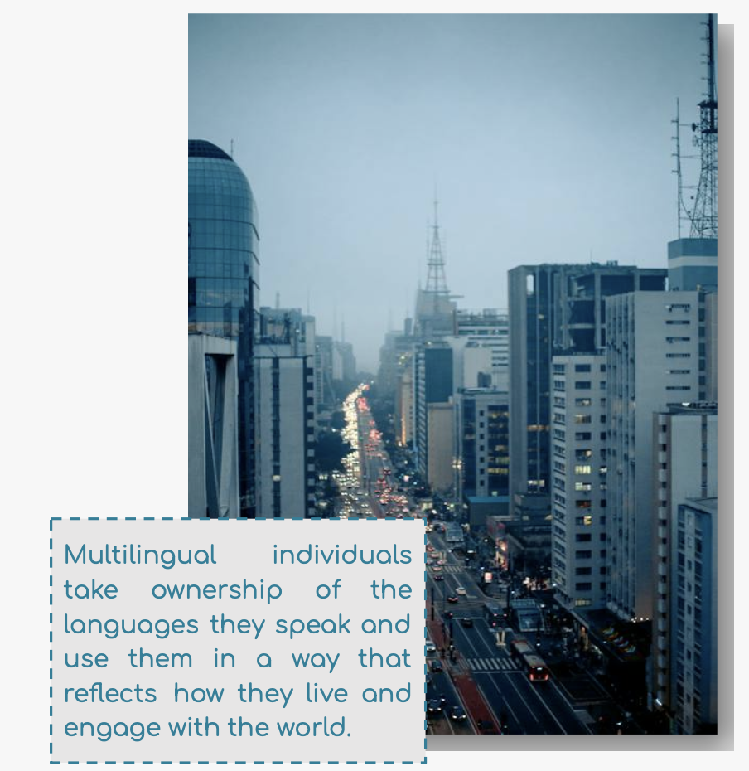

**Multilinguismo**

["Accents" by Denice Frohman](https://youtu.be/84ZcT1jDCjk?si=TJbbXA2Vmy2I3Tkn)

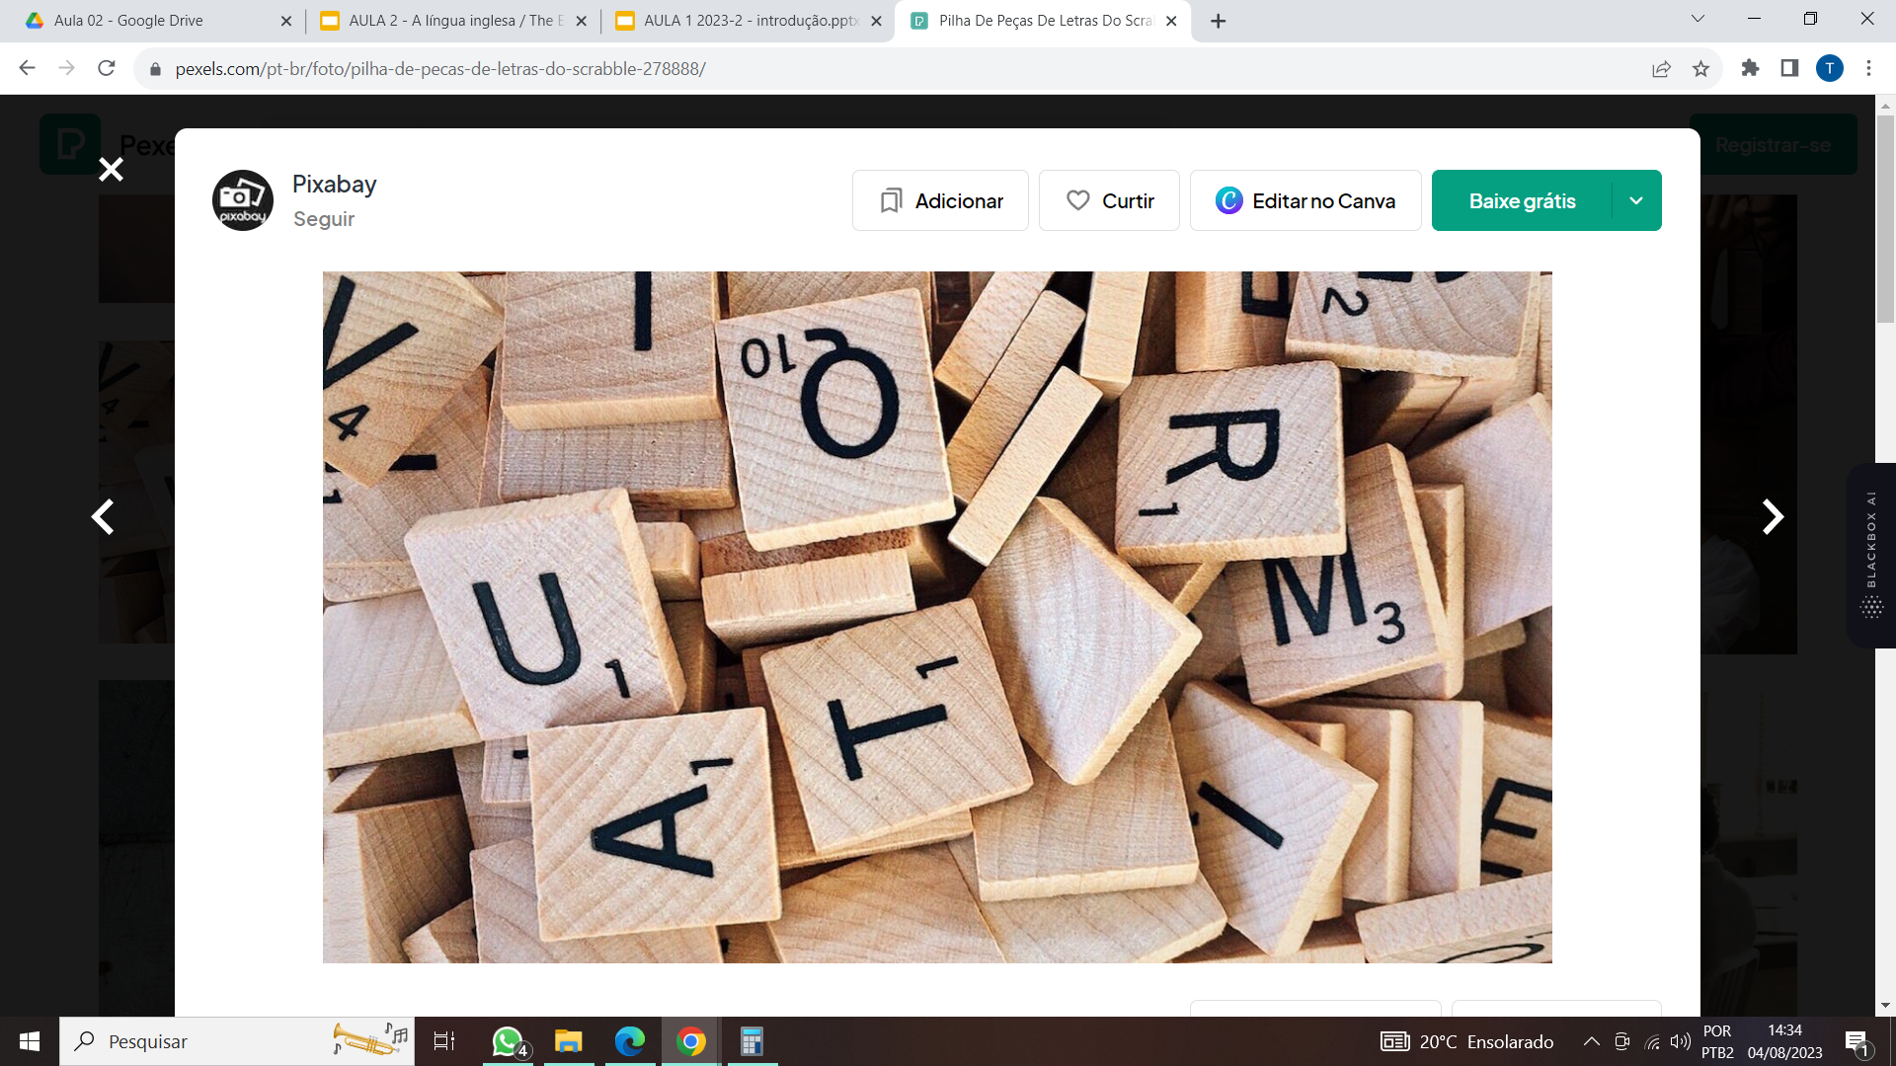

Were any words in the video familiar to you?

Did the images help you understand the video?

**Accents by Denise Frohman**

“she speaks a sanchocho of

Spanish and English”

“English sits in her mouth remixed

so ‘strawberry’ becomes ‘eh­strawbeddy’

and ‘cookie’ becomes ‘eh­cookie’

and kitchen, key chain, and chicken all sound the same”.

* Qual é o seu inglês?

**Listening and Speaking Skills - Tips**

**Tips!**

Do you ever follow any of these tips?

* Watch videos and movies with different accents;
* Listen to music in English;
* Listen to podcasts!;
* Record and listen to yourself
* Play the audio more than once if necessary

**Do you have any questions?**

**Coming next…**

A língua inglesa / The English language

**Thank you!**

*A responsabilidade pela idoneidade, originalidade e licitude dos conteúdos didáticos apresentados é do professor.  
Proibida a reprodução, total ou parcial, sem autorização. Lei 9.610/98.